**Approach and Screenshots of Work force management portal**

**User Login:**

* When user enters the username and password and click Login
* Ajax call for the user Authentication will be called and receive a token.
* Alert the user with “Login Successful”
* Response token is send has a Authorization in Ajax headers to get Employees Details.
* Checks the role name in response data and Navigate window location to **Manager Home page or WFM Manager Home Page**

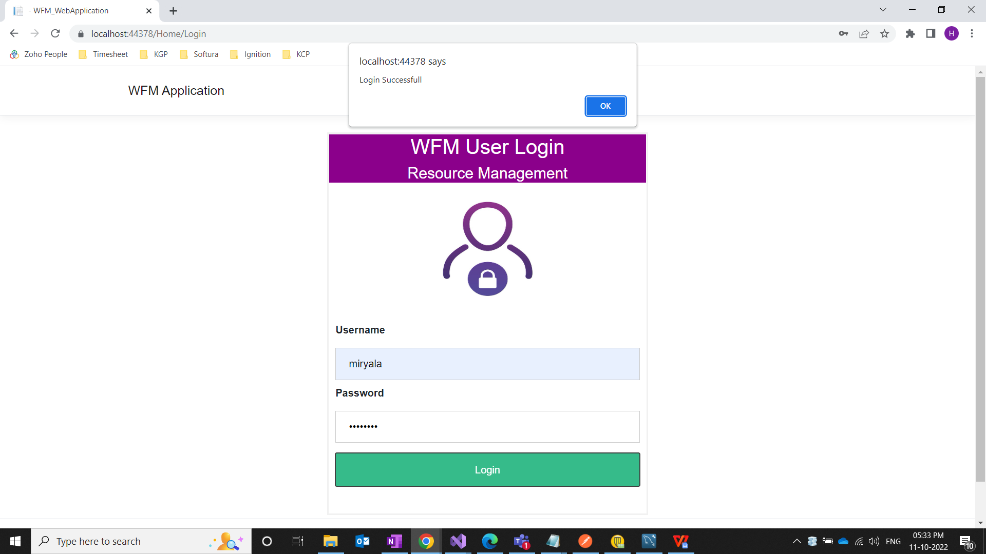

* If Username and password is not correct , it will display **you have an entered an invalid username and password**

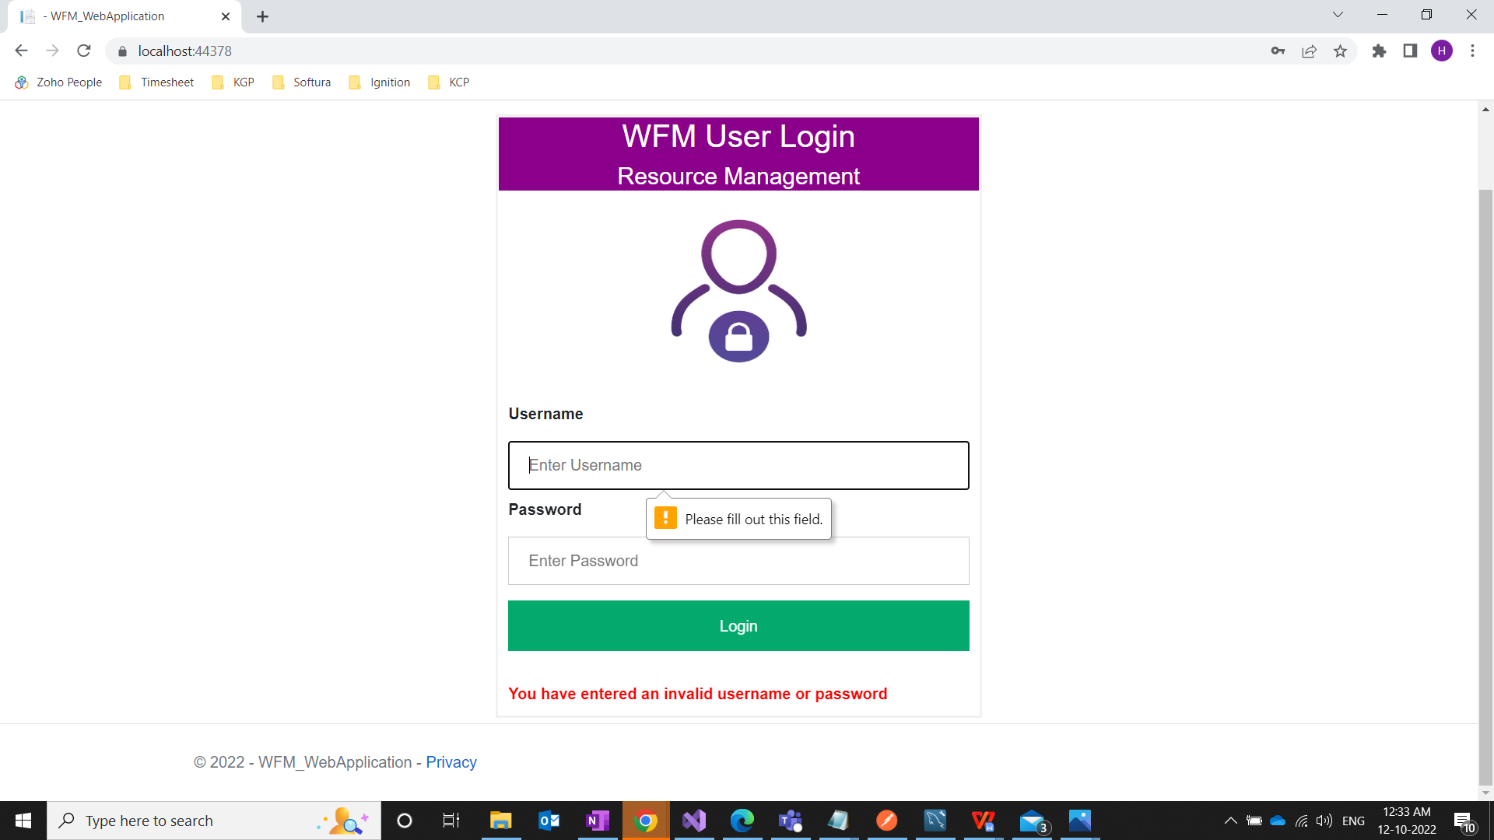

**In Manager Home Page:**

* The Employee Details will be displayed from api get method through the Ajax Call.
* In API get method only the employee details with Lockstatus - NotRequested which is handled through LINQ concepts.

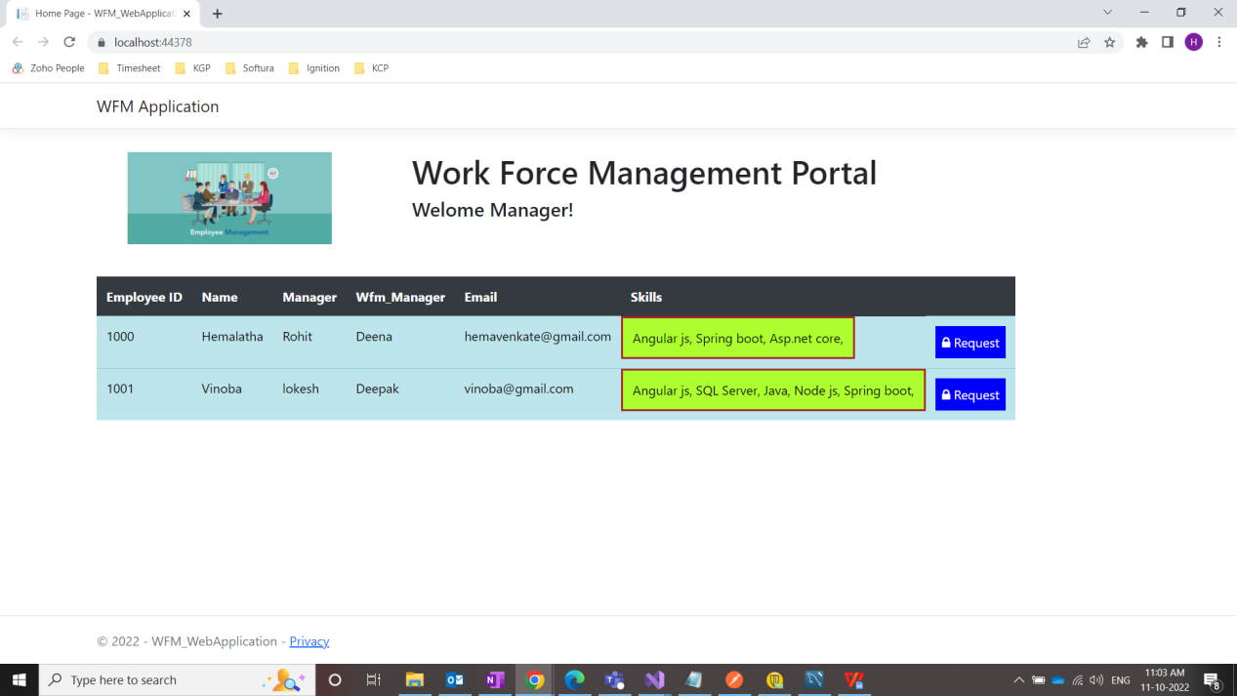

* When Request button is clicked, Softlock form will be Popup and table will be hidden.
* Softlock Form will be displayed with the particular employee id in the table.
* In the Softlock Form, when manager click submit button with Request message.
* Alerts manager Your Employee Request Submitted Successfully or Not. Back to login is also available

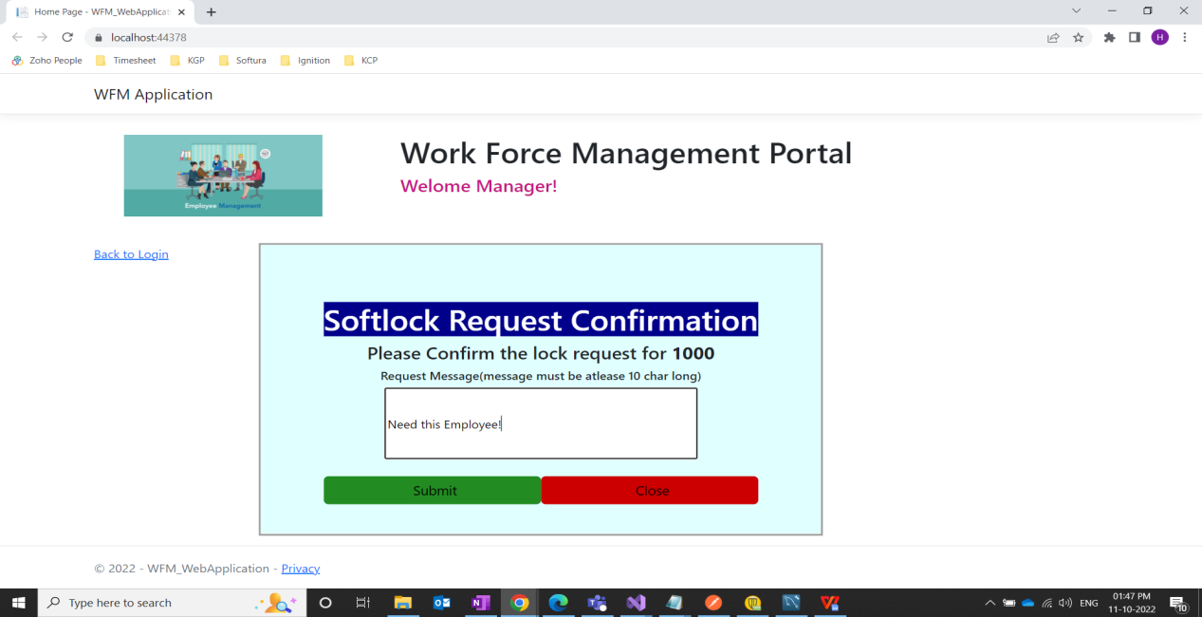

**In WFM Manager Home Page:**

* Display the softlock details which status is awaiting_confirmation will be get through Api and Linq condition.

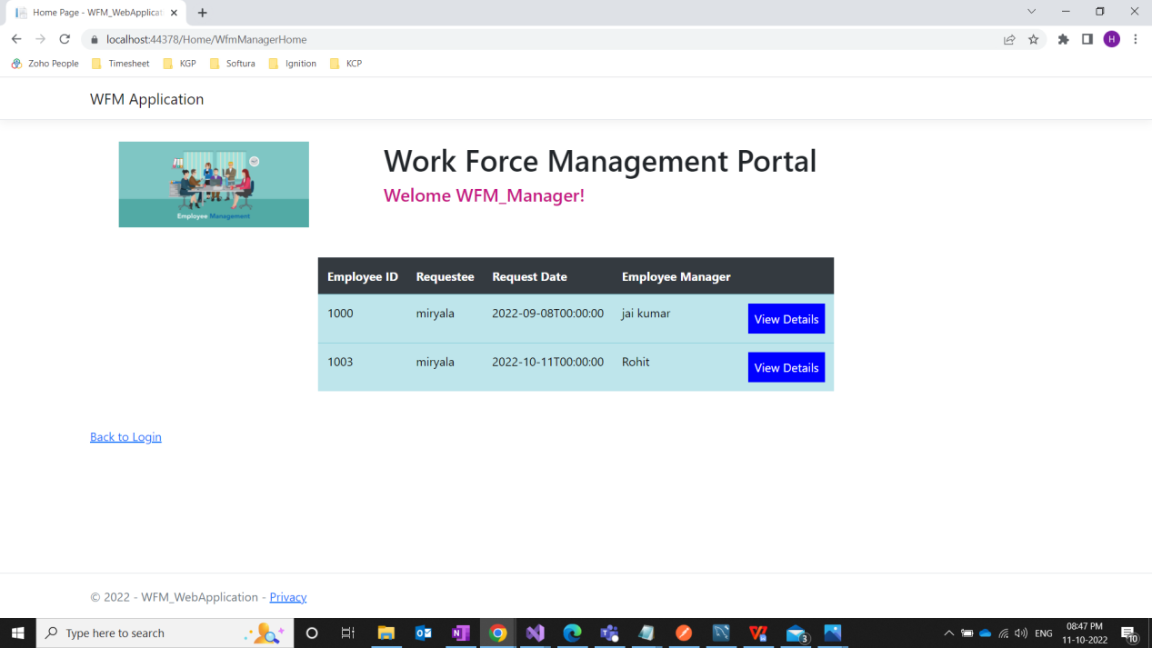

* When Wfm_manager click View Details button , Softlock Form will be poped up.

* The particular employee details will be retrieved with id and displayed in Softlock Request Confirmation Form.

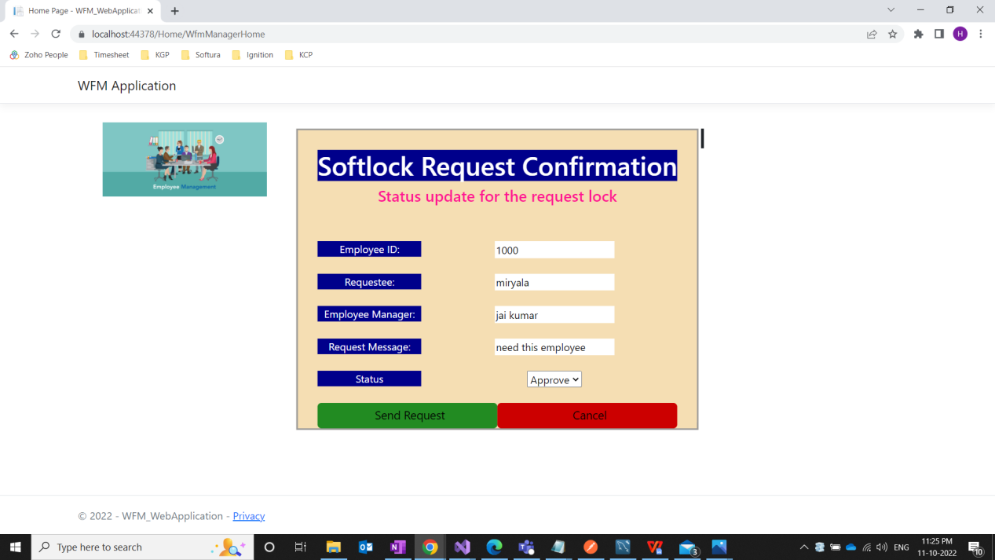

‘

* Here He/she can change the status as Approve or Reject using drop down
* Softlock table will be updated and Employee table LockStatus will be set to Locked with Ajax call.

